Лабораторное задание № 7
1. Создайте хранимые процедуры для операций манипулирования данными.
-- Таблица category

CREATE OR REPLACE FUNCTION save_category(
p_category_id INTEGER,
p_name TEXT,
p_description TEXT
)
RETURNS VOID AS $$
BEGIN
IF p_category_id IS NULL THEN
INSERT INTO category (name_category, description)
VALUES (p_name, p_description);
ELSE
UPDATE category
SET name_category = p_name,
description = p_description
WHERE category_id = p_category_id;
END IF;
END;
$$ LANGUAGE plpgsql;

CREATE OR REPLACE FUNCTION delete_category(p_category_id INTEGER)
RETURNS VOID AS $$
BEGIN
DELETE FROM category
WHERE category_id = p_category_id;
END;
$$ LANGUAGE plpgsql;

-- Таблица product

CREATE OR REPLACE FUNCTION save_product(
p_product_id INTEGER,
p_name TEXT,
p_price FLOAT,
p_quantity INTEGER,
p_category_id INTEGER
)
RETURNS VOID AS $$
BEGIN
IF p_product_id IS NULL THEN
INSERT INTO product (name_product, price, quantity_stock, category_id)
VALUES (p_name, p_price, p_quantity, p_category_id);
ELSE
UPDATE product
SET name_product = p_name,
price = p_price,
quantity_stock = p_quantity,
category_id = p_category_id
WHERE product_id = p_product_id;
END IF;
END;
$$ LANGUAGE plpgsql;

CREATE OR REPLACE FUNCTION delete_product(p_product_id INTEGER)
RETURNS VOID AS $$
BEGIN
DELETE FROM product
WHERE product_id = p_product_id;
END;
$$ LANGUAGE plpgsql;

-- Таблица buyer

CREATE OR REPLACE FUNCTION save_buyer(
p_buyer_id INTEGER,
p_name TEXT,
p_phone VARCHAR(20)
)
RETURNS VOID AS $$
BEGIN
IF p_buyer_id IS NULL THEN
INSERT INTO buyer (name_buyer, phone_number)
VALUES (p_name, p_phone);
ELSE
UPDATE buyer
SET name_buyer = p_name,
phone_number = p_phone
WHERE buyer_id = p_buyer_id;
END IF;
END;
$$ LANGUAGE plpgsql;

CREATE OR REPLACE FUNCTION delete_buyer(p_buyer_id INTEGER)
RETURNS VOID AS $$
BEGIN
DELETE FROM buyer
WHERE buyer_id = p_buyer_id;
END;
$$ LANGUAGE plpgsql;

-- Таблица order_product

CREATE OR REPLACE FUNCTION save_order(
p_order_id INTEGER,
p_status TEXT,
p_buyer_id INTEGER
)
RETURNS VOID AS $$
BEGIN
IF p_order_id IS NULL THEN
INSERT INTO order_product (order_status, buyer_id)
VALUES (p_status, p_buyer_id);
ELSE
UPDATE order_product
SET order_status = p_status,
buyer_id = p_buyer_id
WHERE order_id = p_order_id;
END IF;
END;
$$ LANGUAGE plpgsql;

CREATE OR REPLACE FUNCTION delete_order(p_order_id INTEGER)
RETURNS VOID AS $$
BEGIN
DELETE FROM order_product
WHERE order_id = p_order_id;
END;
$$ LANGUAGE plpgsql;
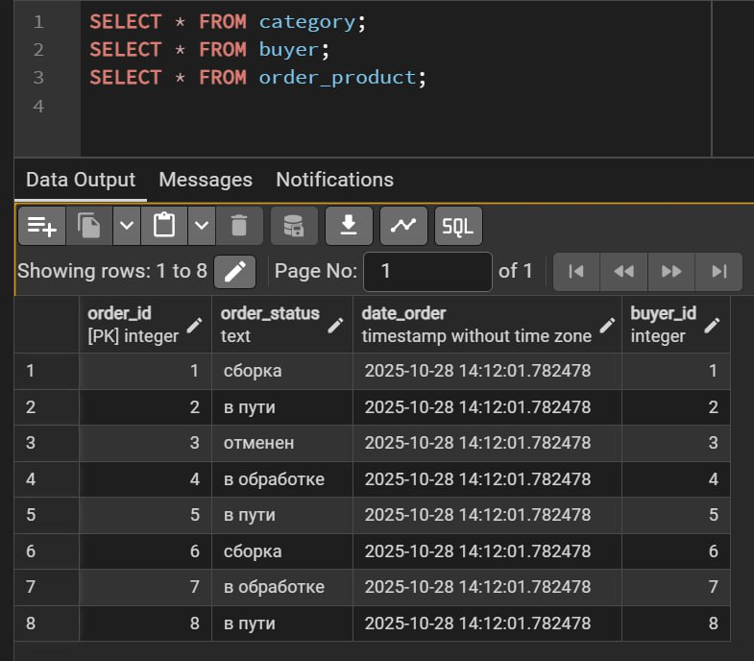
2. Разработайте в базе данных следующие виды функций:
1) Функция с пустыми входными параметрами, результат которой — скалярное выражение
Сколько всего покупателей:
CREATE OR REPLACE FUNCTION fn_total_buyers()
RETURNS INTEGER
LANGUAGE plpgsql
AS $$
DECLARE
v_total INTEGER;
BEGIN
SELECT COUNT(*) INTO v_total
FROM buyer;

RETURN v_total;
END;
$$;
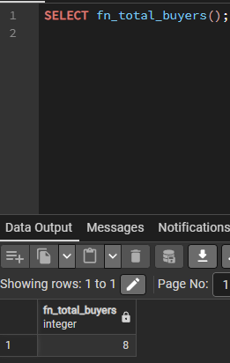
2) Функция со скалярным аргументом, результат которой соответствует типу одного из столбцов существующей таблицы;
По product_id вернуть цену (FLOAT, как столбец price):
CREATE OR REPLACE FUNCTION fn_get_product_price(
p_product_id INT
)
RETURNS FLOAT
LANGUAGE plpgsql
AS $$
DECLARE
v_price FLOAT;
BEGIN
SELECT price
INTO v_price
FROM product
WHERE product_id = p_product_id;

IF v_price IS NULL THEN
RAISE EXCEPTION 'Товар с id % не найден', p_product_id;
END IF;

RETURN v_price;
END;
$$;
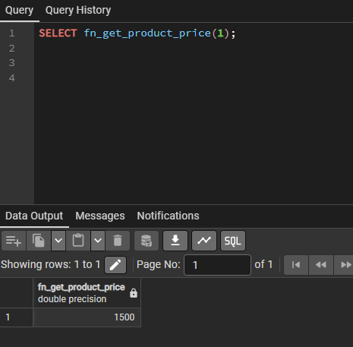
3) Функция с выходными параметрами, определёнными с помощью OUT.
CREATE OR REPLACE FUNCTION fn_buyer_orders_stats(
p_buyer_id INT,
OUT total_orders INT,
OUT first_order TIMESTAMP,
OUT last_order TIMESTAMP,
OUT info_text TEXT
)
RETURNS RECORD
LANGUAGE plpgsql
AS $$
DECLARE
rec RECORD;
BEGIN
total_orders := 0;
first_order := NULL;
last_order := NULL;
info_text := NULL;

PERFORM 1 FROM buyer WHERE buyer_id = p_buyer_id;
IF NOT FOUND THEN
RAISE EXCEPTION 'Покупатель с id % не найден', p_buyer_id;
END IF;

BEGIN
FOR rec IN
SELECT date_order
FROM order_product
WHERE buyer_id = p_buyer_id
ORDER BY date_order
LOOP
total_orders := total_orders + 1;

IF first_order IS NULL THEN
first_order := rec.date_order;
END IF;

last_order := rec.date_order;
END LOOP;

IF total_orders = 0 THEN
info_text := 'У покупателя ещё нет заказов';
ELSE
info_text := 'Количество заказов: ' || total_orders ||
', период: ' || first_order || ' — ' || last_order;
END IF;

EXCEPTION
WHEN others THEN
RAISE NOTICE 'Ошибка при расчёте статистики по покупателю %: %',
p_buyer_id, SQLERRM;
total_orders := 0;
first_order := NULL;
last_order := NULL;
info_text := 'Произошла ошибка при расчёте статистики';
END;
END;
$$;
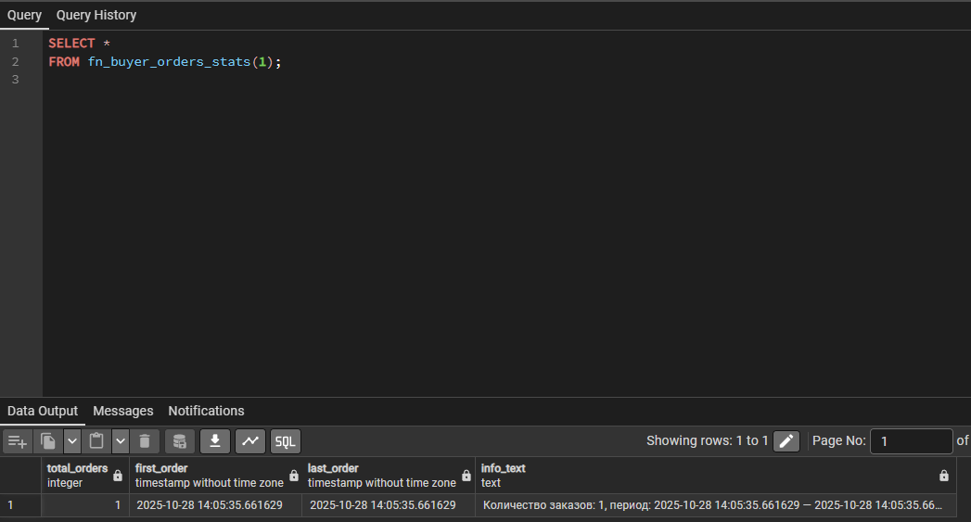
3. Создайте резервную копию базы данных

